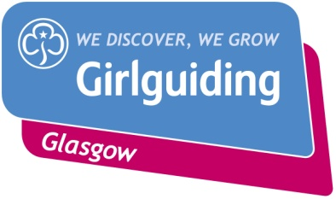

GIRLGUIDING GLASGOW

100 YEAR CELEBRATION BADGE

|  |  |  |
| --- | --- | --- |
| Contact Name |  | |
| Unit & Division |  | |
| Contact Address |  | |
| Post Code |  | |
| Telephone Number |  | |
| Email Address |  | |
| No. of badges required |  | At £1 each |
| Payment made by:  Delete as appropriate | Cheque | Bank Transfer |

Please make cheque’s payable to: **Girlguiding Glasgow**

Send to: 100 Year Celebration Badge

Girlguiding Glasgow

15 Elmbank Street

Glasgow G2 4PB

Or by Bank Transfer to: **Guide Association, City of Glasgow**

Sorting Code: 83-91-46 Account No. 20401103

Reference No. **7777/(Your Unit Number)**

Email form to: [office@girlguidingglasgow.org.uk](mailto:office@girlguidingglasgow.org.uk)

**Office Use:**

|  |  |  |
| --- | --- | --- |
| Badges sent : | Date:  Number of badges: | Cheque recd/Bank Transfer |