FIRE ACTION PLAN AT ACHACHAIRDEIS GARTOCHARN
Note this is a legal requirement which all leaders must comply with and indicate they have completed actions.
Leaders to test the fire equipment located at front doors in Napier House, Fasdagh, Caladh, camp hut and test fire doors open. Sign log book at Napier House.
- Camp Hut back door and side door must be left unlocked when camp hut is being used and when site is being used.
- Leaders to ensure that all are aware on what to do in the event of a fire.
- All leaders must acquaint themselves with fire equipment, evacuation points, assembly points and the new fire alarm sounders showing all how to operate in the event of fire.
- Leaders must carry out fire evacuation tests ensuring all are aware on what to do in the event of a fire.
- Ensure emergency exits are not blocked by any equipment including shoes/boots etc.
Testing Alarm on arrival and as part of fire evacuation process.
Press Yellow once, then red once to test alarm which is loud, then press red again to turn off then press green to re set alarm.
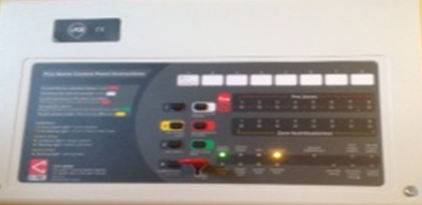
- Recap Yellow, red, then red again and green to re set.
- There are a number of small red fire alarm activations at emergency exits, same as one in this picture. All must be advised this activation alarm must be used to alert all to evacuate the building in the event of a fire.
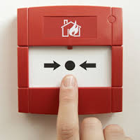

Actions to Take When Discovering a Fire at Achachairdeis buildings or campsite.
- Napier House, Fasdagh, Caladh and camp hut Press red fire alarm sounder and immediately leave the building and report to assembly points.
- For campsite shout a verbal warning to others in the vicinity and report to Assembly points.
- Call the Fire service – 999
- Inform members of staff, volunteers and assemble with others well clear of the building at the Assembly Point which is for Fasdagh and Napier House the Flagpole. Campsite/camp hut and Caladh is car park.
- Do not obstruct emergency services vehicles
- Do not re-enter any buildings or tents until advised to do so
- Remain at the assembly Point until you receive further instructions from the Emergency Services
Napier House
When using Napier House please ensure the following actions are carried out:
Fire Exits
- Ensure that both fire exits are able to open and any closure mechanism is removed.
- Ensure all are aware of location of fire alarm sounder
Heating
- If using the standalone heaters please ensure they are not close to any other furniture
Kitchen
- If you want hot water for washing dishes or washing hands, please turn on using the switch at the left hand side of entrance.
- Switch on the urn at the wall for hot water/drinks or use the kettle for hot drinks.

Smoke/Alarm
- Test Fire/Smoke alarms ensuring they operate
- Fire log record
- Ensure fire log is completed and that you have completed testing fire doors, smoke/fire alarms, fire evacuation and report anything that is not operational to OOA
Fire Evacuation Test
- Undertake emergency fire evacuation procedures and ensure this is logged in Fire log book kept at Napier House just inside the door
When leaving Napier House please ensure the following are carried out:
Fire Exits
- Please ensure the fire exits are closed.
Heating
- If standalone heaters have been used please switch them off and remove plugs from sockets
- Please ensure heating is turned off
Kitchen
- Please switch off appliances excluding Fridge
- Please switch off the urn and kettles at sockets
General
- Please place tables in metal cage and stack dining chairs
- Please check all rooms and toilet areas are clear to ensure no one is inadvertently ‘locked in’
- Please switch off all lights
Camp Hut
- First leader on site to test Fire Alarm is operation and process for doors
- On entering camp hut at all times please ensure the back door is unbolted and unlocked as this is emergency exit. All leaders must adhere to this.
- Exit can be closed in the evening, but must be re-opened when being used.
- Log book to be signed to confirm all understand requirements
Campsite
- Fire Evacuation test
- Undertake emergency fire evacuation procedures and ensure this is logged in Fire log book kept at Napier House just inside the door.

Caladh
- Ensure that all understand how to evacuate the building.
- Test fire/smoke alarms to ensure they are operational
- Undertake emergency fire evacuation procedures and ensure this is logged in Fire log book kept at Napier House just inside the door
- All leaders to understand and read fire action plan
Fasdagh
- Ensure that all understand how to evacuate the building.
- Test fire/smoke alarms to ensure they are operational
- Undertake emergency fire evacuation procedures and ensure this is logged in Fire log book kept at Napier House just inside the door
- All leaders to understand and read fire action plan

I understand the role I have on discovering a fire and I understand how to operate the emergency exits in Napier House, location of emergency exits for Caladh, Fasgadh, understand the access route from Caladh, Fasdagh, camp hut, how to undertake fire evacuation and necessary requirements for completion in fire log book located in Napier House.

Name:
Role:
Date:
Signature:

